CHICKENPOX

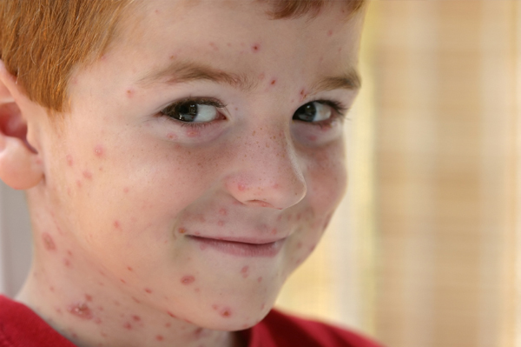
Chicken pox is a contagious disease caused by the varicella virus, which causes an itchy rash all over body. It is most common in children.
- Chicken pox is usually not serious, especially in children, but can be more severe in adults,

- It can spread easily. You can get it from an infected person who sneezes, coughs, or shares food or drinks. You can also get it if you touch the fluid from a chickenpox blister.
What are the symptoms? 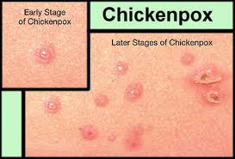
- The first symptoms of chickenpox often are a fever, a headache, and a sore throat.
- The chickenpox rash usually appears about 1 or 2 days after the first symptoms start.
Some children get the chickenpox rash without having a fever or other early symptoms.
Chicken pox blisters are extremely itchy
- But scratching can cause scarring and invite infection.
- Apply calamine lotion to your child's body to sooth the itching, but don't use it on your child's face. Cool baths may also bring your child some relief.
- Cut your child's nails short to limit the damage the scratching may inflict.
Things you’ll need.
- Calamine lotion, Cocoa butter ,Vitamin E oil, Over-the-counter scar removal cream
- Treat fever, a common symptom of chicken pox, and any pain with acetaminophen or ibuprofen
- Chicken pox sores in your mouth can make it uncomfortable for your child to eat or drink. Minimize your child's discomfort by only preparing soft, bland foods. Spicy, acidic, salty and crunchy foods can irritate the sores.
- You or your child can go back to work, school, or day care when all blisters have crusted over. This is usually about 10 days after the first symptoms start.

