Report on an Inventor
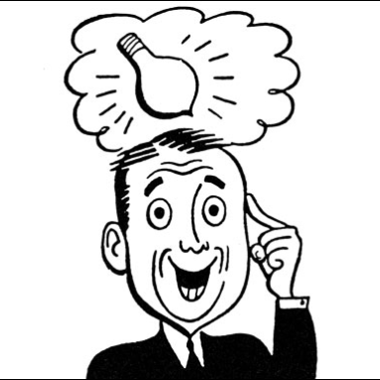
You have been provided with a famous Inventor. You will need to write a report on this person and how they changed the world. Before you can start writing you will need to research (find things about) your inventor and their invention. Try to find out as many details about your inventor as you can.
Name of Inventor: _____________________________
When your inventor was born: _____________________________
Where did your inventor live: _____________________________
What did your inventor invent: _____________________________
How did your inventor do this: _____________________________
Where did your inventor get the idea for this: _____________________________
What is this invention used for: _____________________________
How has this invention changed the world: _____________________________
What would the world be like without this invention: ___________________________________________________________________
___________________________________________________________________
___________________________________________________________________
___________________________________________________________________
__________________________________________________________________
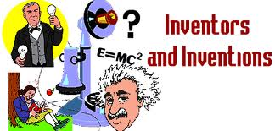

What other information can you find about your inventor and their invention?
*You do not need to find out all this information, but the more you have the easier it will be to write your report.

Inventor’s Childhood: _____________________________________________________________________________________
_____________________________________________________________________________________
_____________________________________________________________________________________

Inventor’s Education – What type of schooling did your inventor have:
_____________________________________________________________________________________
_____________________________________________________________________________________
_____________________________________________________________________________________

Inventor’s Adult Life:
_____________________________________________________________________________________
_____________________________________________________________________________________
_____________________________________________________________________________________

